**Requirements Document for Firebase connection and App layout.**

|  |  |  |  |
| --- | --- | --- | --- |
| **Date** | **Version** | **Author** | **Description** |
| 9th Jan 19 | 1.0 | Chetan Prasad | Initial Version |

# **App requirements**

1. **App shall provide a splash screen.**
2. **App shall provide Firebase login. (I have already implemented this feature. I can provide the code for you)**
3. **The app shall check if internet connection is present.**
4. **The app shall access the location of the device and shall be able to store in the database when required.**
5. **App shall have Navigation Drawer**

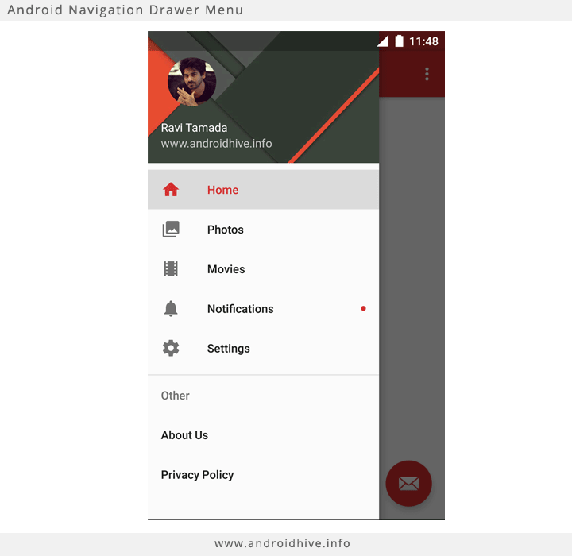

It shall have the following items.

* Name and email id (profile photo not required)
* OnBoarding
* Basic Electronics Tutorial
* Link to Website
* Link to Youtube channel, facebook and instagram
* About Us
* Privacy Policy

1. **The App shall provide onboarding screens to help user to get started.**

* The onboarding screens shall be customisable.
* Onboarding screens should be able to play Gif file format.
* Onboarding screen shall be displayed only the first time the app is opened.
* There shall be an option to view onboarding screens from the Navigation drawer.
* Reference for Onboarding screens: <https://blog.iamsuleiman.com/onboarding-android-viewpager-google-way/>

1. **The activity shall have the layout as shown below.**



* The activity shall be a scrollable activity so that when new buttons are added it shall be easy to view.
* The Button size shall remain consistent both in landscape and portrait mode.
* The Buttons color shall change on button press.
  1. **“List 1” Requirements**
* **“List 1”** shall be a drop down box.
* **“List 1”** shall contain 2 fixed values called “Demo” and “Individual”.
* **“List 1”** shall read the rest of the values from the database.